ELCT 302
Laboratory Notebook #3
Control Design and Implementation
Group #2B (Steering Control)
December 8th, 2023

I hereby certify that I have complied
with the Spirit and the Letter
of the Carolinian Creed
in preparing this report

Mady Hines
Mady Hines

Department of Electrical Engineering
University of South Carolina
Columbia, SC 29208
Table of Contents
Time Sheet 2
General Objectives 3
Main Specifications 3
Plan of Action (Procedure) 3
Background 3
Tasks: Steering Control Design and Simulation 3
MATLAB Plots: 6
Simulink Plots: 11
Tasks: Control Implementation 13
Questions 14
Problems 15
Requirements 15

Steering Control (Group B)

Time Sheet
Date/Amount of Time | Work Done
10/16: 2 hours | Read Lab 3 requirements.
10/23: 2 hours | Started MATLAB code
10/30: 3 hours | Soldered sensors and tested them.
11/6: 3 hours | Worked on Simulink model and collected data for the table.
Check-off: 12/7

General Objectives
❖ Design a closed-loop DC motor controller and determine necessary coefficient values
➢Proportional-derivative control (PD)
❖ Simulate open vs. closed-loop system continuous time response using MATLAB
❖ Determine system stability by its transfer function using the Nyquist stability criterion
➢ Simulate the discretized closed-loop system model using Simulink software; compare with continuous time MATLAB results
❖ Implementation of micro-controller based closed-loop DC motor control
❖ Testing and validation of the complete control system
❖ System Analysis
➢ Time Response
➢ Bode plot, gain margin, phase margin
➢ Nyquist plot and Nyquist criteria for stability

Main Specifications
❖ Servo voltage: 4.8V - 6V
❖ Communication frequency: 50Hz
❖ Servo Rotational range: 180⁰
❖ Feedback: LC circuit for a given inductance (at 20 kHz)

Plan of Action (Procedure)

Background
We have finally modeled the servo motor to be used with this system using estimation techniques. This should have produced a system transfer function that relates the input control signal to output steering angle. The second part of the system being a dynamic model, given in state space representation. The next part, how do we combine these two to effectively achieve the overall forward path transfer function. First we will need to convert the dynamic model into a transfer function.
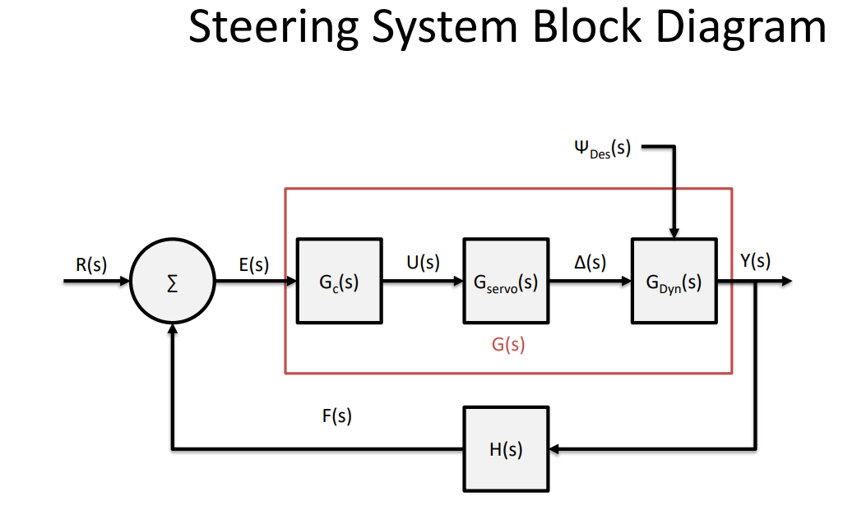

Tasks: Steering Control Design and Simulation
❖ Research data sheets for components and understand why they are used (their ratings)
❖ Determine appropriate gains (conversion factors) present in your system (i.e. gear ratio, frequency-to-voltage, ADC, etc.) put into Matlab
➢ The ADC gain can be noted as a normalized value due to mbed software.
➢ Normally you would need the associated bit value representation for the Analog to Digital Converter (ADC) and the Digital to Analog Converter (DAC).
❖ UNDERSTAND the provided Matlab code and each plotted figure, explanations will be expected.
➢ You may need to alter some code in order to get more effective plots.
➢ Make note of the resulting ‘kp’ and ‘kd’ values in your lab notebook.
➢ Determine stability from bode plot
➢ Determine stability from Nyquist plot
❖ Build system model in Simulink including gains, the feedback loop, and a discretized PD controller.
➢ For sample time ‘ti’ and the controller’s unit delay use 1 kHz for this lab.
❖ Plot step response using a three-channel scope in Simulink.
➢ Step Input
➢ Controller Output
➢ System Output
❖ Inject disturbances to the system and insure rejection from controller.
➢ Change in steer angle
▪ Introduce disturbance to the angle for one time step
➢ Controller Saturation.
▪ When the controller exceeds the physical limitation.
▪ Be able to explain the concept and show in a plot.
❖ Tabularize results as follows:
➢ Note some information will not be available till the implementation phase
Performance Characteristics Descriptions:
- Rise Time: The time taken for the system to go from 10% to 90% of the step input value.
Simulink: (3.386, 0.08454)
- Overshoot: The amount by which the system exceeds the desired step input value.

Simulink: (6.822, 0.111)
- Undershoot: If applicable, the amount by which the system initially falls below the desired step input value.
Simulink: N/A
- Steady State Error: The difference between the final output and the desired step input value.
- Settling Time: The time taken for the system to enter and remain within a certain percentage (commonly 2% or 5%) of the step input value.
Simulink: (9.818, 0.1094)

 | Rise Time | Overshoot | Undershoot | Steady State Error | Settling Time
System Measurement
MATLAB (continuous) | 2.4837 | 2.0741 | 3.9187 | 0 | 6.2629
Simulink (discrete) | 3.386 | 1.11e-01 | 0 | 0.3 | 9.8178
Percent Error:  (Mat. VS Sim) | 36.33% | 94.70% | 100% | 100% | 56.76%
Percent Error: (Mat. VS Sys)
Percent Error (Sim. VS Sys)
*MATLAB: The continuous system analysis.
*Simulink: The discrete system simulation.
*Real System

MATLAB Plots:
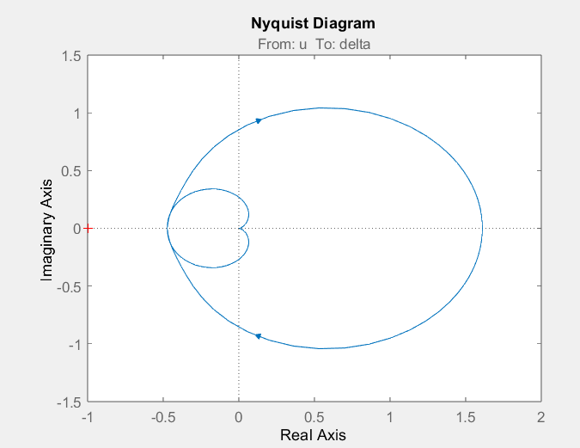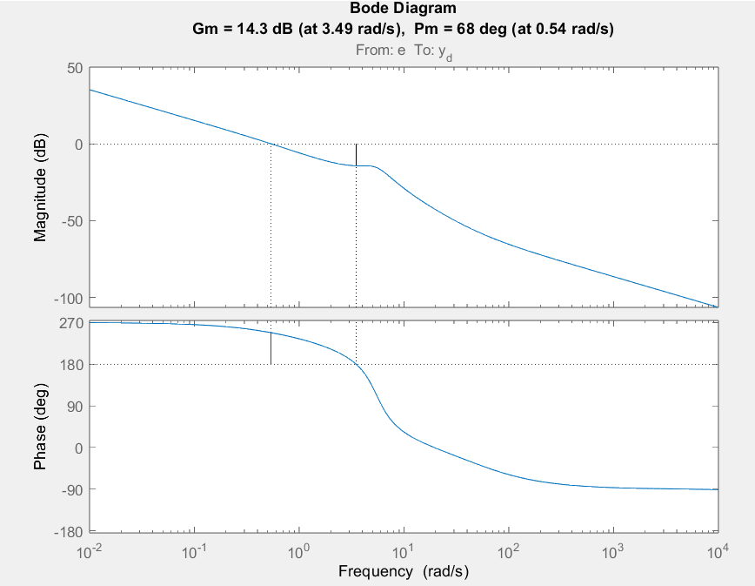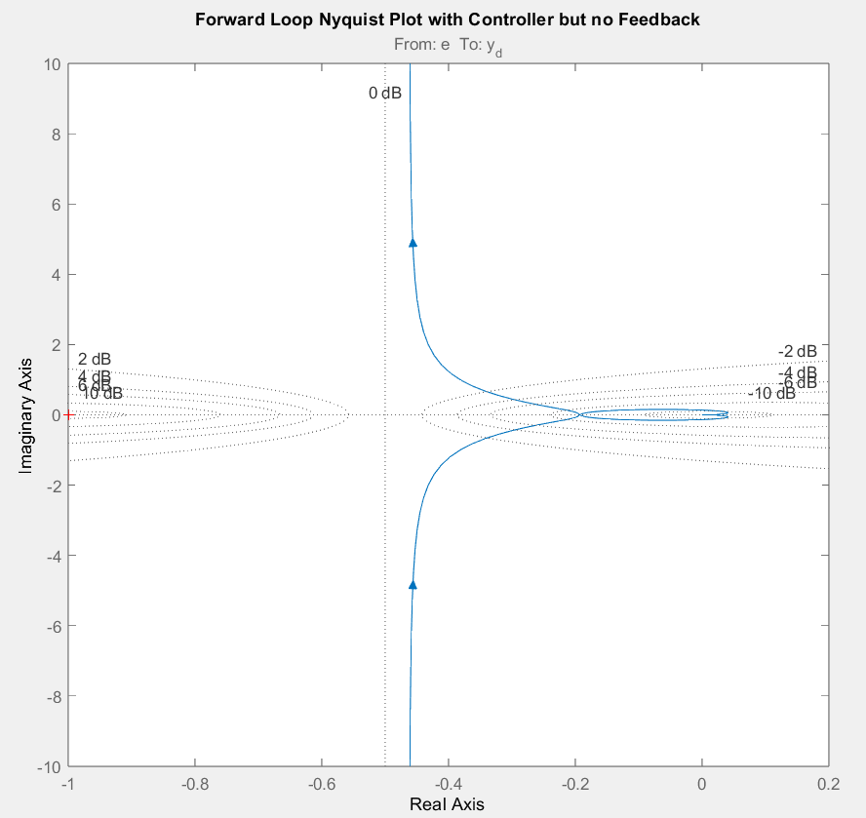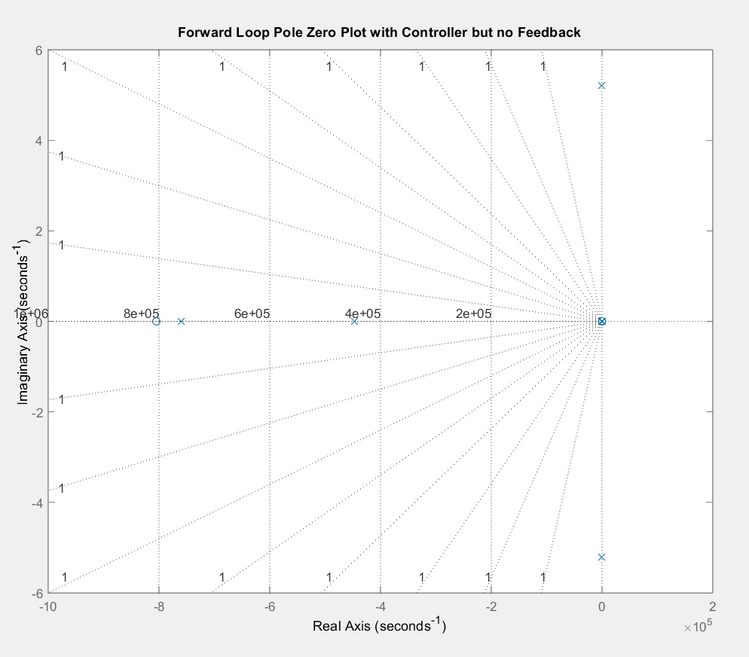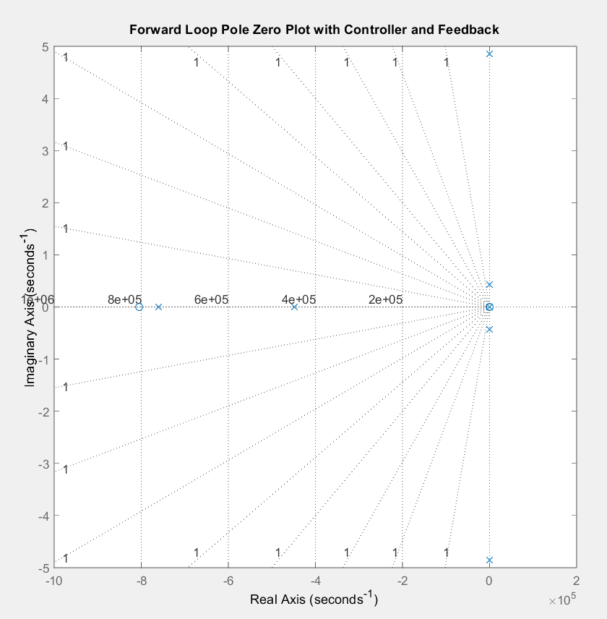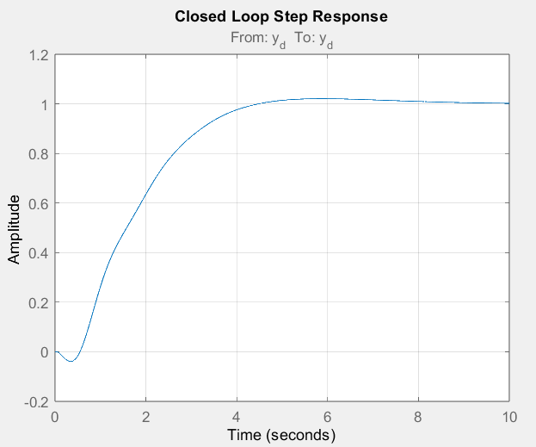

Simulink Plots:
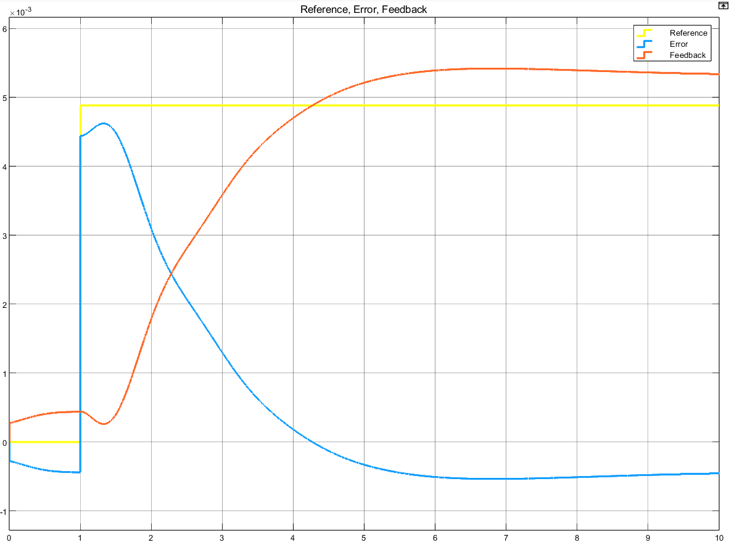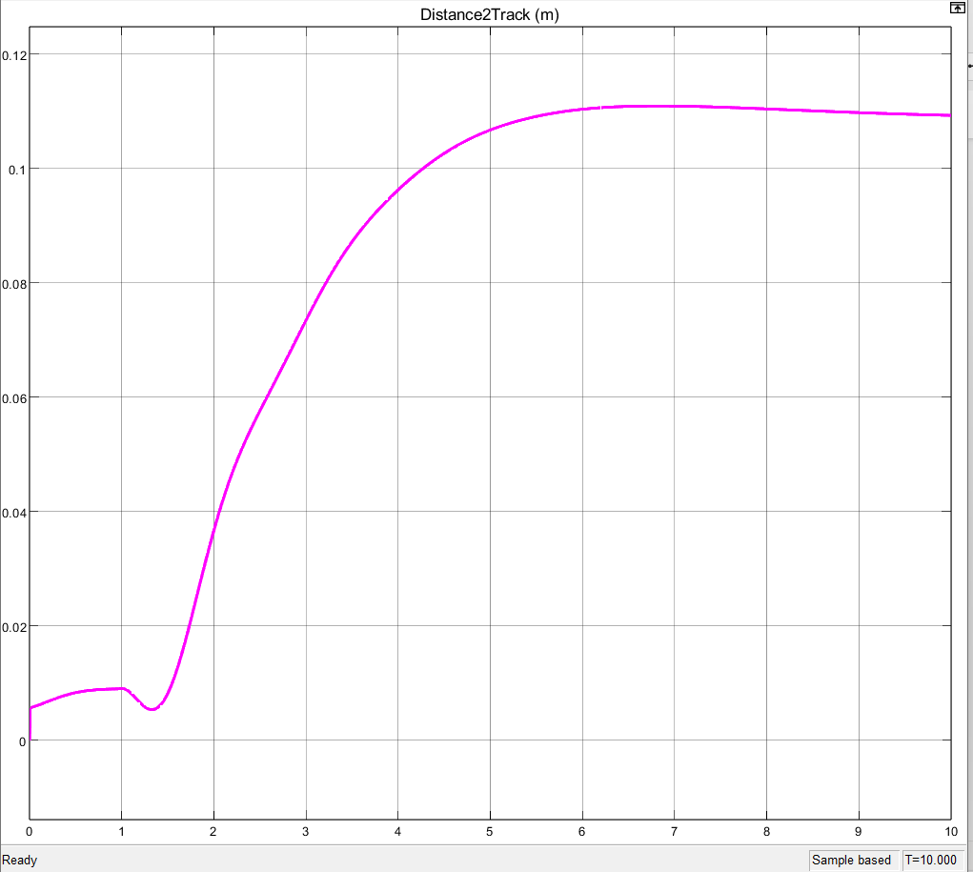

Tasks: Control Implementation
❖ Using mbed, program the microcontroller and test closed-loop controller operation
➢ Use First Order Taylor Series approximation method to implement the following PD controller in the discrete domain.
➢ Use a software interrupt in order to sample the current position and update the PWM duty cycle at a predetermined interval. Call this interval interrupt time ‘TI’.
➢ Constants can be set as compiler defines at the top of code or in ‘.h’ files:
#define TI 0.001 %1kHz sample time
#define KP 1.0f %Proportional Gain
#define KD 1.0f %Derivative Gain
➢ The PD controller can be represented as follows:
𝑢(𝑡) = 𝑘𝑝𝑒(𝑡) + 𝑘𝐷𝑒̇(𝑡)
Equation 22 – PI controller in continuous time
➢ The PD controller with Eular forward approximation can be implemented in code as: errorChange(i)= (error(i) - error(i-1))/TI;
controllerOutput(i) = KP*error(i) + KD*errorChange(i);
➢ Note these are given for a standard PD controller and not a PD + bias controller. You will need to incorporate the bias term.
❖ Measure your system’s no-load bandwidth in simulation.

Questions
1) What is the fundamental difference between the simulation in Matlab and the simulation in Simulink? a) Hint: Time domain
- MATLAB: continuous
- Simulink: discrete
2) Is the controller designed in the discrete time domain or continuous time domain? a) Hint: Have you been taught discrete control design?
- The controller is designed in continuous time domain.
3) Is the control implementation in the continuous domain? If not, how do we determine the discrete controller is stable in our operational range?
- The controller is implemented in discrete time domain.
4) Is there some way to limit the effect from a sudden change in the reference signal of the system?
a) Hint: Research Derivative Kick
- Yes, there is a way. The low pass filter would be the easiest to implement due to our knowledge level on the subject matter.
5) How did you determine the no load bandwidth and what frequencies can be rejected?
a) Does this match the input waveform performance?
- We determined the no lad bandwidth by generating a Bode Plot in MATLAB.
  - The bandwidth of the system is generally determined by thew –3 dB point of the gain for the system.

Problems
Problems: | Solutions:
Difficulty figuring out Kp and Kd values. | Trial and error
Had issues with MATLAB and Simulink. | Lots of research
Difficulty implementing to real system. | Trial and Error

Requirements
❖ Check-off requirements:
➢ Implantation of controller must use software interrupt (ticker function)
➢ Comparison for Simulations and Implementation
▪ Tabularized comparison chart completed
➢ Description of derivation for control gains
➢ Description of stability
▪ Bode Plot
▪ Nyquist stability criterion
➢ Completion and demonstration of control implementation
▪ You may push the car with a pole or similar object, trying to maintain a constant set speed.
❖ Check-off report: (Group)
➢ Refer to rubric and template from Blackboard
➢ Be sure to include:
▪ Results presentation (include o-scope images, measurement records, etc.)
▪ Results analysis and discussion
▪ Hardware schematic (using PSpice, TinyCAD, EAGLE, etc.)
▪ Problem-solving (describe problems you encountered and how you solved them)

